- \(…)\Strip transfer\Strip transfer, slide-Unit C
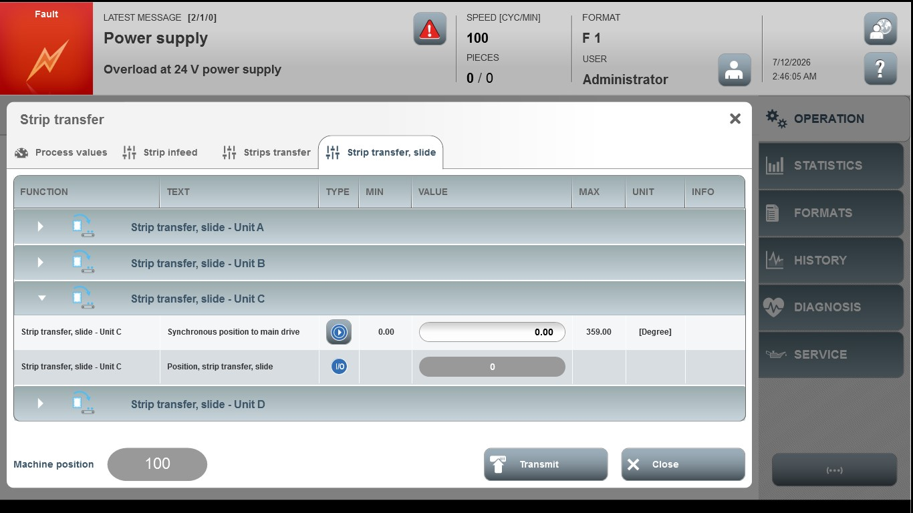
Acceptance criterion | Limits | Pass / Fail: Dev-No. | Date | Initials
Screen matches screenshot | N / A
Synchronous position to main drive | 0.00…359.00

